**Lab 2: Android Context Menu**

# **Introduction**

When a user long presses or clicks on an element in Android, a context menu similar to a floating menu appears. This menu can be used to carry out actions that have an impact on the currently chosen content or context frame. The context menu on Android is more akin to the selection that appears when you right-click in Windows or Linux. Here is a visual depiction of how to use the context menu in our Android apps.

**Let’s get Started:**

In this Exercise we will be implementing a **Context Menu** in the android application.

**Step 1**: open an **activity_main.xml** file from **\res\layout** path and write the code like as shown below.

**activity_main.xml**

*<?*xml version="1.0" encoding="utf-8"*?>*<RelativeLayout xmlns:android="http://schemas.android.com/apk/res/android"  
 xmlns:app="http://schemas.android.com/apk/res-auto"  
 xmlns:tools="http://schemas.android.com/tools"  
 android:layout_width="match_parent"  
 android:layout_height="match_parent"  
 tools:context=".MainActivity">  
  
 *<!-- creating text view for displaying heading-->* <TextView  
 android:id="@+id/idTVHeading"  
 android:layout_width="match_parent"  
 android:layout_height="wrap_content"  
 android:layout_above="@id/idTVMessage"  
 android:layout_marginStart="20dp"  
 android:layout_marginTop="20dp"  
 android:layout_marginEnd="20dp"  
 android:layout_marginBottom="20dp"  
 android:gravity="center"  
 android:text="Hello Snapchat!"  
 android:textAlignment="center"  
 android:textAllCaps="false"  
 android:textColor="#FF000000"  
 android:textSize="20sp"  
 android:textStyle="bold" />  
  
 *<!-- text view for displaying the selected menu item-->* <TextView  
 android:id="@+id/idTVMessage"  
 android:layout_width="match_parent"  
 android:layout_height="wrap_content"  
 android:layout_centerInParent="true"  
 android:layout_margin="20dp"  
 android:gravity="center"  
 android:text="Choose Programming Language"  
 android:textAlignment="center"  
 android:textAllCaps="false"  
 android:textColor="#FF000000"  
 android:textSize="20sp"  
 android:textStyle="bold" />  
  
</RelativeLayout>

**Step2:**

Open main [activity](https://www.tutlane.com/tutorial/android/android-activity-lifecycle) file MainActivity.kt and write the code like as shown below.

**MainActivity.kt**

package com.example.demopluralsightcontextmenu  
  
import android.os.Bundle  
import android.support.v7.app.AppCompatActivity  
import android.view.ContextMenu  
import android.view.MenuItem  
import android.view.View  
import android.widget.TextView  
  
class MainActivity : AppCompatActivity() {  
  
 *// creating variables for video view on below line.* lateinit var messageTV: TextView  
  
 override fun onCreate(savedInstanceState: Bundle?) {  
 super.onCreate(savedInstanceState)  
 setContentView(R.layout.*activity_main*)  
 *// initializing variable for video view on below line.* messageTV = findViewById(R.id.*idTVMessage*)  
 *// registering context menu on below line.* registerForContextMenu(messageTV)  
 }  
  
 override fun onCreateContextMenu(  
 menu: ContextMenu?,  
 v: View?,  
 menuInfo: ContextMenu.ContextMenuInfo?  
 ) {  
 super.onCreateContextMenu(menu, v, menuInfo)  
 *// on below line we are setting header title for menu.* menu!!.setHeaderTitle("Choose Programming Language")  
 *// on below line we are adding menu items* menu.add(0, v!!.getId(), 0, "Java")  
 menu.add(0, v!!.getId(), 0, "Kotlin")  
 menu.add(0, v!!.getId(), 0, "Dart")  
 }  
  
 override fun onContextItemSelected(item: MenuItem): Boolean {  
 *// on below line we are setting the selected item text for message text view* messageTV.*text* = item.*title* return true  
 }  
}

**Step 3: Check Output on Android Emulator and it should look like as given below.**

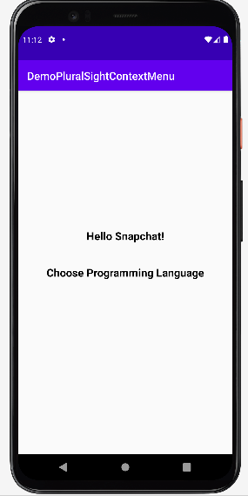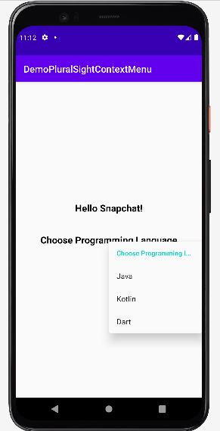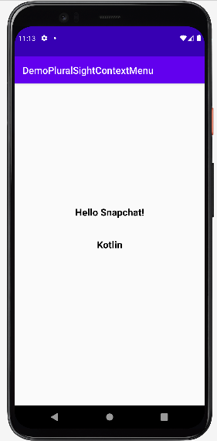

**Voila!!** We have successfully completed this lab.